

International Study Centre
Engineering, Science and Computing (ESC) Department
XFX1062 Computer Hardware

Tutor Name:
Project Title: Design and Implementation of a Simple Computer Using Logisim (Part 2)
Date of Submission: 2nd February 2025

Student Name: | Abdul Raffay
Student ID. Number: | 2652814

Computer Hardware
Final Project Assessment Semester 1
Design and Development of an 8-Bit Microprocessor

Table of Contents
1. Introduction
2. Overview of the 8-Bit CPU
3. Component-by-Component Analysis
3.1 Memory Cell
3.2 Registers
3.3 Memory Address Register (MAR)
3.4 Arithmetic Logic Unit (ALU)
3.5 Decimal Decoder
3.6 Control Unit Part 1 (CU 1)
3.7 Control Unit Part 2 (CU 2)
4. Data Path and Bus Architecture
5. Instruction Set
6. Testing
7. Limitations
8. Improvements
9. Conclusion
10. References
1. Introduction
Computing systems, regardless of their scale or complexity, rest on the same foundational principles: binary data must be stored, moved between components, processed arithmetically and logically, and directed by a governing control mechanism that sequences each operation in the correct order. This project puts those principles into direct practice by constructing a fully functional 8-bit computer using the Logisim digital circuit simulation environment.

Every component was designed from first principles, starting with the most basic storage element (a single D flip-flop memory cell) and building upward through 8-bit registers, a 4-bit memory address register, a seven-operation ALU, a ROM-based decimal decoder, and a two-part hardwired control unit. The completed design is capable of executing seven distinct instructions and displays its results through a dedicated output register connected to a decimal decoder.

2. Overview of the 8-Bit CPU
The CPU follows a Von Neumann architecture, in which a single RAM module serves both as program storage and data memory. The data path is 8 bits wide throughout: all registers, buses, and the ALU operate on values ranging from 0 (00000000) to 255 (11111111). The address bus is 4 bits wide, allowing the CPU to address 16 distinct memory locations (0x0 through 0xF).

The full CPU shown in Figure 1 integrates the following subsystems: Program Counter, Instruction Register, Register A, Register B, MAR, MDR/MBR, Output Register, RAM, Decimal Decoders, the 8-Bit ALU, and the Control Unit (1-2). An 8-bit Internal Data Bus (D7–D0) and a 4-bit Internal Address Bus carry signals between all components.

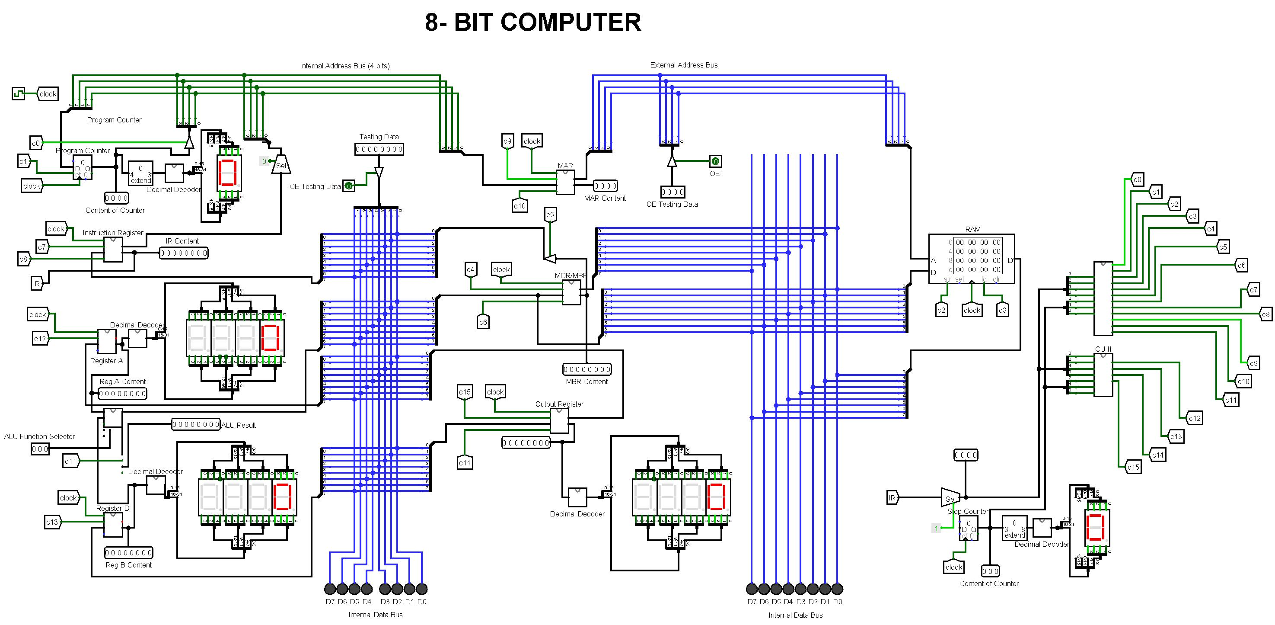
Figure 1: Complete '8-BIT Microprocessor’

The table below summarises every major subsystem and its role:

Component | Bit Width | Role
Program Counter (PC) | 8-bit | Holds address of the next instruction; incremented each fetch cycle
Instruction Register (IR) | 8-bit | Stores the current fetched instruction; upper bits drive the CU as OPC3–OPC0
Register A | 8-bit | Primary ALU operand and accumulator register
Register B | 8-bit | Secondary ALU operand register
MAR | 4-bit | Memory Address Register — drives the RAM address input
MDR / MBR | 8-bit | Memory Data/Buffer Register — transfers data to and from RAM
Output Register | 8-bit | Holds computed result for display via Decimal Decoder
RAM | 4-bit × 8 | Program and data storage; 16 addressable locations
8-Bit ALU | 8-bit | Performs ADD, SUB, MUL, DIV, AND, OR, XOR via a MUX
Decimal Decoder | 8-bit in | ROM-based lookup for display output encoding
Control Unit (CU1+CU2) | — | Hardwired decoder producing control signals C0–C15

3. Component-by-Component Analysis

3.1 Memory Cell
Description
A memory cell is the most fundamental unit of data storage within a digital system. In this design, each memory cell is constructed using a D-type flip-flop, which stores a single binary bit — either a logic 0 or a logic 1. The flip-flop captures its input on the rising edge of the clock signal and holds that value stable until the next clock cycle or until a write signal is asserted. An array of eight such cells forms a single 8-bit register, and a grid of these registers constitutes the RAM module used in the CPU.

Functionality
- Stores a single binary bit persistently across clock cycles
- Controlled by a Write Enable signal to prevent unintended overwrites
- Triggered on the rising edge of the system clock
- Output Enable (OE) controls whether the stored value is driven onto the data bus
- Reset pin forces the stored value to 0 immediately when asserted
- Forms the atomic building block for all registers and RAM arrays in this CPU

Logisim Construction
- Place a D flip-flop from the Memory library; connect the Clr (clear) pin to the Reset input
- Add a NOT gate on the Write Enable line to generate its complement
- Wire an AND gate: inputs are Write Enable and Data Input — this is the write path
- Wire a second AND gate: inputs are NOT(Write Enable) and Q — this holds the current value when WE is low
- Connect the outputs of both AND gates into an OR gate; connect the OR output to the D input of the flip-flop
- Connect the Clock input pin to the flip-flop's clock input
- Place a tri-state buffer on the Q output; connect its control line to the Output Enable pin — this produces the Data Output
- Connect Q directly to a separate Stored Data output pin (no tri-state buffer needed here)

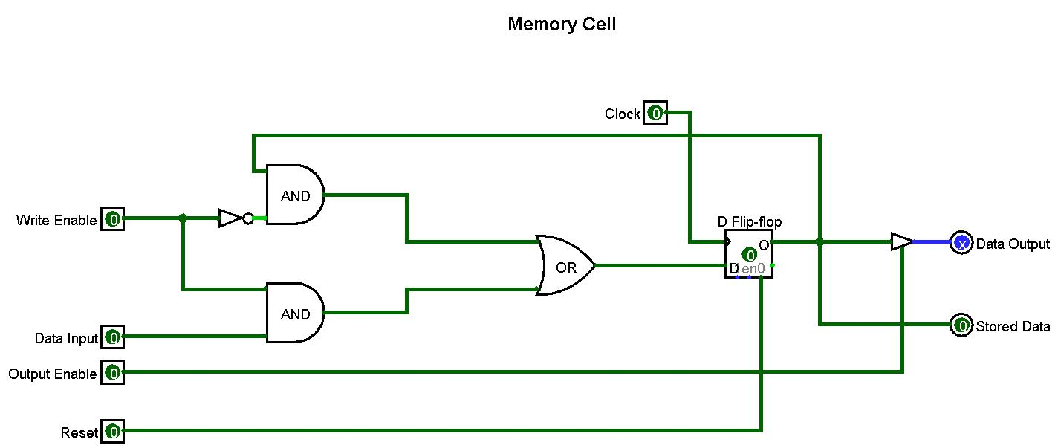
Figure 2: Memory Cell circuit

3.2 Registers
Description
The Registers subcircuit constructs an 8-bit register by placing eight Memory Cell instances in parallel, numbered 0 through 7. All eight cells share the same Clock, Write Enable (w), and Output Enable (oe) control lines. The Data Input is an 8-bit bus (d0–d7), split so that each bit connects to the corresponding cell. The outputs form an 8-bit Data Output bus (o0–o7) via tri-state buffers and a separate 8-bit Stored Data bus (s0–s7) direct from each cell's Q output.

Functionality
- Stores an 8-bit binary value using eight parallel Memory Cell instances
- All eight bits are written simultaneously on a single clock edge when Write Enable is asserted
- Output Enable opens all eight tri-state buffers at once, placing the full 8-bit value onto the bus
- Stored Data output provides a permanent read of the register contents without asserting OE
- Used in this CPU as Register A, Register B, Instruction Register, MDR/MBR, and Output Register

Logisim Construction
- Create a new subcircuit named 'Registers'
- Place eight Memory Cell subcircuit instances, arranged in two columns of four, numbered 0–7
- Add input pins: Clock (1-bit), Write Enable (1-bit), Output Enable (1-bit), Data Input (8-bit)
- Use a Splitter to break the 8-bit Data Input into eight 1-bit wires; connect each to the corresponding cell's Din pin
- Connect Clock, Write Enable, and Output Enable from the input pins to all eight cells in parallel
- Use a second Splitter to recombine the eight o0–o7 outputs into an 8-bit Data Output pin
- Similarly combine the eight s0–s7 outputs into an 8-bit Stored Data output pin

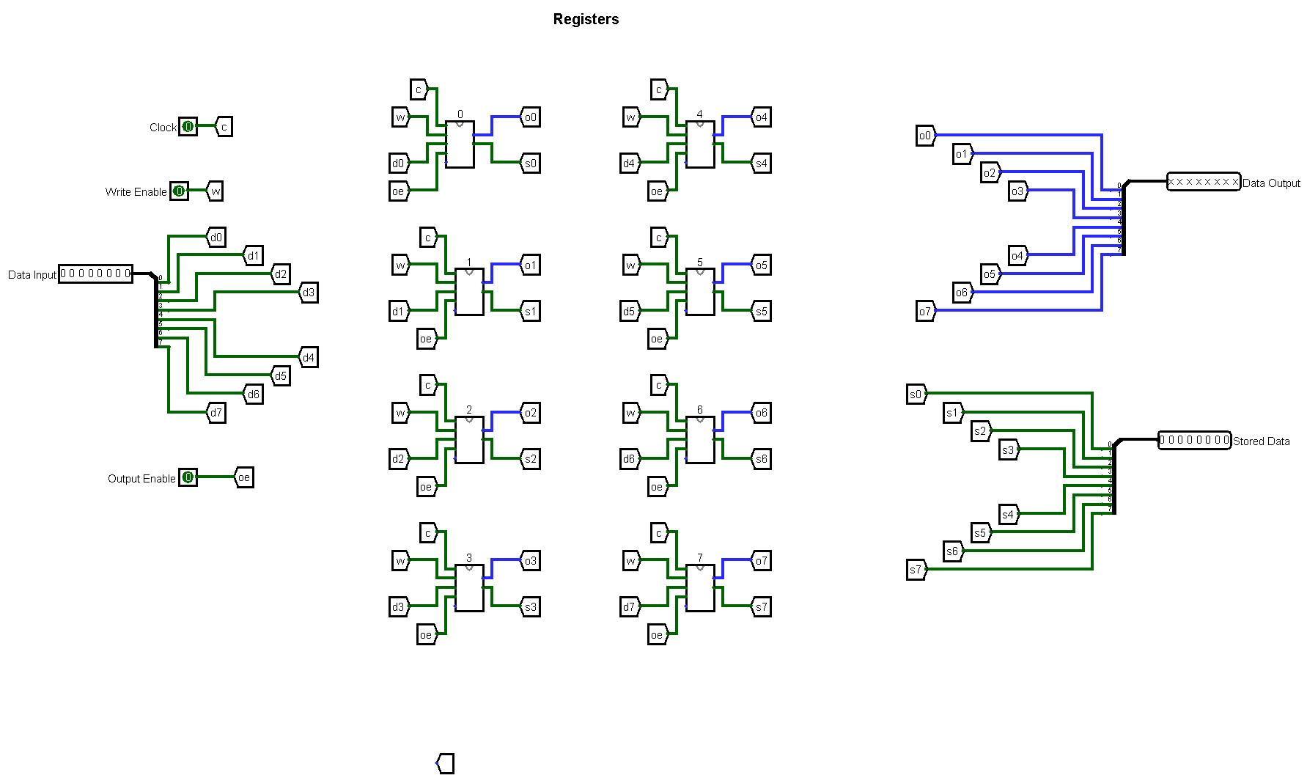
Figure 3: Registers subcircuit

3.3 Memory Address Register (MAR)
Description
The Memory Address Register (MAR) follows the same construction pattern as the Registers subcircuit but uses only four Memory Cell instances (numbered 0–3), making it a 4-bit register. Its purpose is to hold the target memory address whenever the CPU needs to read from or write to RAM. The 4-bit width allows access to 16 memory locations (addresses 0000–1111 in binary). The Stored Data output of the MAR drives the RAM address input directly and also appears on the External Address Bus.

Functionality
- Holds the current 4-bit memory address for RAM access
- Loaded from the Program Counter during the fetch cycle
- Loaded from the instruction operand during the execute cycle for data memory operations
- Stored Data output drives the RAM address input — no OE assertion needed for this path
- Data Output (tri-state, OE-controlled) allows the address value to be placed back on the internal bus if required

Logisim Construction
- Create a new subcircuit named 'MAR'
- Place four Memory Cell instances, numbered 0–3
- Add input pins: Clock (1-bit), Write Enable (1-bit), Output Enable (1-bit), Data Input (4-bit)
- Use a Splitter to break the 4-bit Data Input into four 1-bit wires; connect each to the corresponding cell's Din
- Connect Clock, Write Enable, and Output Enable to all four cells in parallel
- Combine the four o0–o3 outputs into a 4-bit Data Output pin
- Combine the four s0–s3 outputs into a 4-bit Stored Data output pin
- In the main CPU canvas: wire the MAR Stored Data output to the RAM's address input

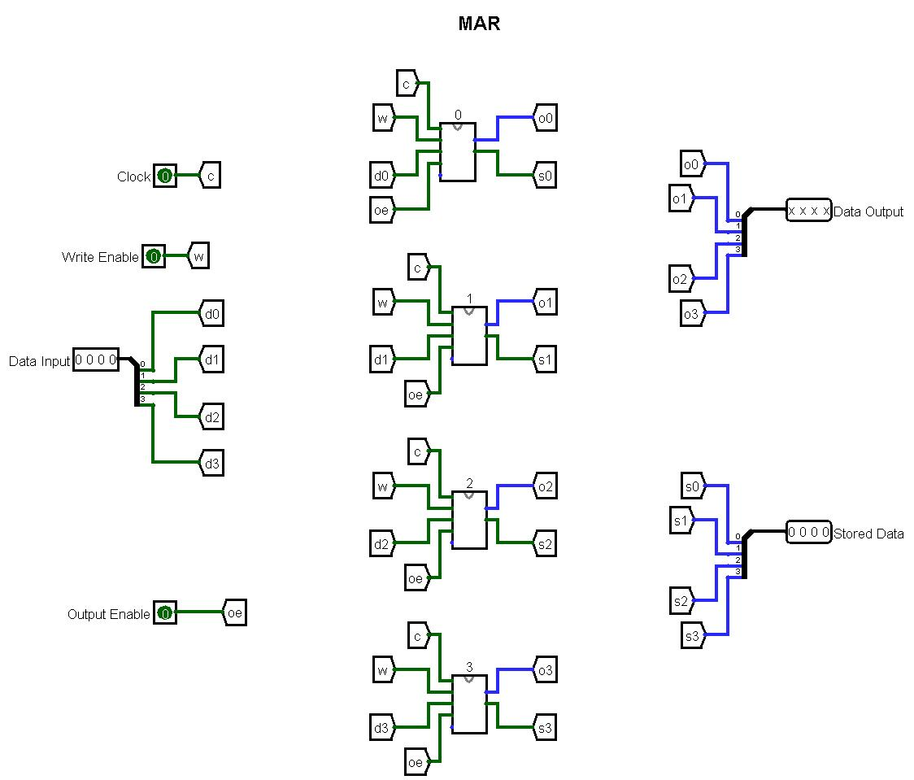
Figure 4: MAR subcircuit

3.4 Arithmetic Logic Unit (ALU)
Description
The 8-Bit ALU takes two 8-bit operands — Reg A and Reg B — and performs one of seven operations selected by a 3-bit Function Selector input. All seven operation blocks run simultaneously; the MUX routes the selected result to the Data Output and ALU Result output pins. An Output Enable pin controls whether the result is driven onto the internal data bus. Carry/borrow flag outputs are produced for each arithmetic operation.

Functionality
Operation | MUX Sel | Flag Output | Type
ADD — Addition | 000 | Carry out + | arithmetic
SUB — Subtraction | 001 | Carry out − | arithmetic
MUL — Multiplication | 010 | Carry out × | arithmetic
DIV — Division | 011 | Carry out / (upper + rem) | arithmetic
AND — Bitwise AND | 100 | — | logic
OR — Bitwise OR | 101 | — | logic
XOR — Bitwise XOR | 110 | — | logic

Logisim Construction
- Place an Adder from the Arithmetic library (8-bit); connect A and B inputs; label carry-out 'Carry out +'
- Place a Subtractor; connect A and B inputs; label borrow-out 'Carry out −'
- Place a Multiplier; connect inputs; label carry-out 'Carry out ×'
- Place a Divider; connect inputs; label outputs 'upper' (quotient) and 'rem' (remainder); combine as 'Carry out /'
- Add an AND gate (8-bit) from the Gates library; connect Reg A and Reg B
- Add an OR gate (8-bit); connect Reg A and Reg B
- Add an XOR gate (8-bit); connect Reg A and Reg B
- Connect all seven results to a 7-to-1 MUX from the Plexers library
- Add a 3-bit input pin labelled 'Function Selector'; connect to the MUX select input
- Connect MUX output to 'Data Output' and 'ALU Result' output pins
- Add an Output Enable pin connected to a tri-state buffer on the Data Output line

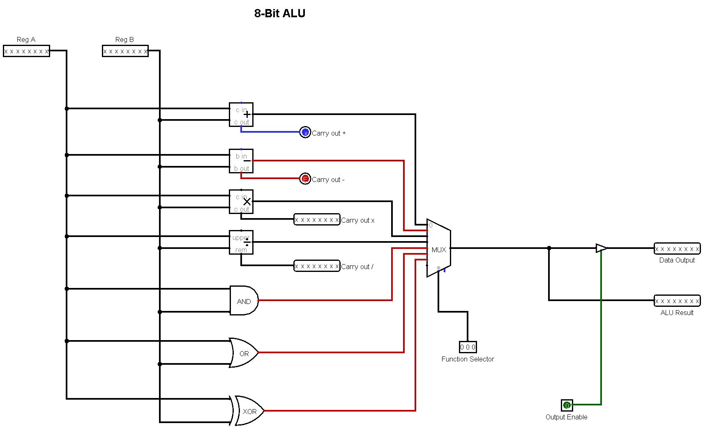
Figure 5: 8-Bit ALU

3.5 Decimal Decoder
Description
The Decimal Decoder translates an 8-bit binary input into display-ready output patterns using a ROM lookup table. The 8-bit Data Input addresses the ROM, which contains four pre-programmed 32-bit values at their belonged addresses. These are seven-segment display encoding patterns. The 32-bit ROM output is split by Splitter components into four 8-bit groups, each driving a separate Data Output line.

Functionality
- Receives the 8-bit value from the Output Register as its address input
- Selects the pre-stored encoding pattern from the ROM at that address
- Splits the 32-bit ROM output into four 8-bit display output lines
- Provides human-readable output of the computed result without affecting CPU operation
- ROM contents can be updated to support additional display encodings

Logisim Construction
- Place a ROM component from the Memory library; set address width to 8 bits, data width to 32 bits
- Right-click the ROM → 'Edit Contents'; add a file for Decimal Decode
- Connect the 8-bit Data Input pin to the ROM's address input (A)
- Place four Splitter components to divide the 32-bit ROM output (D) into four 8-bit groups
- Connect each 8-bit group to a separate Data Output pin
- In the main CPU canvas: wire the Output Register's Stored Data output to the Decimal Decoder's Data Input

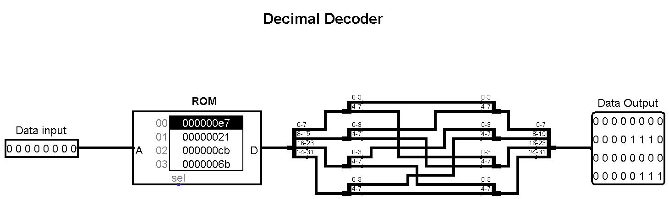
Figure 6: Decimal Decoder — ROM

3.6 Control Unit Part 1 (CU 1)
Description
CU 1 is the first half of the instruction decoding logic. It receives four opcode bits (OPC3, OPC2, OPC1, OPC0) from the Instruction Register and three step-counter bits (SC2, SC1, SC0) indicating the current micro-step. Using columns of NOT gates and multi-input AND gates, it produces twelve control signal outputs: C0 through C11. Each output goes high for exactly one specific combination of opcode and step, activating the corresponding component action.

Functionality
- Decodes the instruction opcode (OPC3–OPC0) combined with the execution step (SC2–SC0)
- Generates control signals C0–C11, each corresponding to a specific CPU micro-operation
- Each output is the result of a single AND gate whose inputs are a specific mix of true/complemented OPC and SC signals
- Operates combinationally — outputs change instantly with no clock delay
- Works in parallel with CU 2 to produce the complete set of 16 control signals

Logisim Construction
- Create a subcircuit named 'CU 1'; add seven input pins: OPC3, OPC2, OPC1, OPC0, SC2, SC1, SC0
- Add twelve output pins: C0, C1, C2, C3, C4, C5, C6, C7, C8, C9, C10, C11
- Place NOT gates on each of the seven inputs to generate their complements
- For each output Cn: place a multi-input AND gate; connect the required true or complemented OPC/SC inputs
- Use Logisim Tunnels (Wiring library) to route the many input wires to each AND gate without crossing lines
- Connect each AND gate output to its corresponding labelled output pin

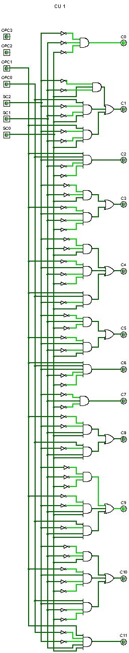
Figure 7: CU 1

3.7 Control Unit Part 2 (CU 2)
Description
CU 2 extends the control unit logic using identical inputs to CU 1 (OPC3–OPC0, SC2–SC0) but producing the final four control signals: C12, C13, C14, and C15. These cover the instructions or micro-steps not handled by CU 1. The circuit is more compact — only four AND gate rows — reflecting the smaller number of additional control signals needed. In the main CPU canvas, both CU 1 and CU 2 are instantiated with their inputs connected in parallel.

Functionality
- Produces control signals C12, C13, C14, C15 — extending CU 1's C0–C11
- Same seven OPC/SC inputs as CU 1; both circuits operate simultaneously
- Each of the four AND gates implement a distinct instruction-and-step minterm
- Together, CU 1 and CU 2 form a complete 16-signal hardwired control word

Logisim Construction
- Create a subcircuit named 'CU 2'; add the same seven input pins as CU 1: OPC3, OPC2, OPC1, OPC0, SC2, SC1, SC0
- Add four output pins: C12, C13, C14, C15
- Place NOT gates on all seven inputs
- For each of C12–C15: place an AND gate with the appropriate OPC/SC combination
- Wire each AND gate output to its corresponding output pin
- In the main CPU canvas: instantiate both CU 1 and CU 2; connect all shared inputs in parallel using Tunnels

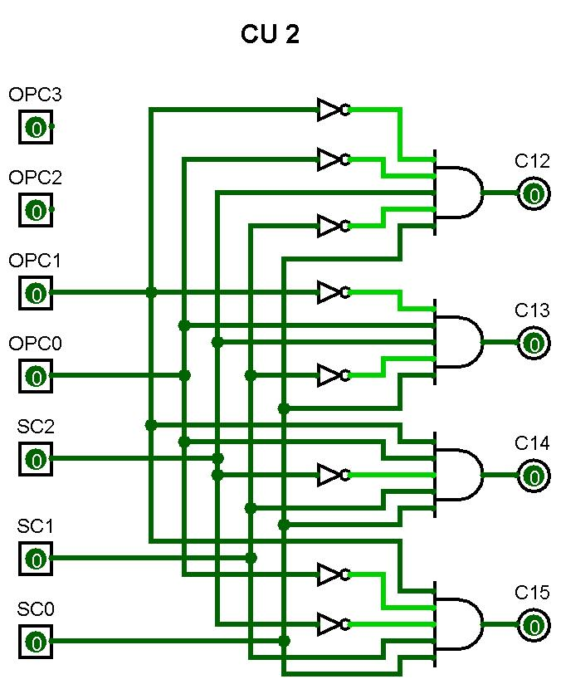
Figure 8: CU 2

4. Data Path and Bus Architecture
Data movement within the CPU is managed by three distinct buses, each carrying a different category of signal:

Bus | Width | Direction | Purpose
Internal Data Bus (blue) | 8-bit | Bidirectional | Transfers data between registers, ALU, and MDR/MBR
Internal Address Bus | 4-bit | CPU → RAM | Carries the MAR output to the RAM address input
External Address Bus | 4-bit | CPU → External | Exposes the memory address for external observation/testing
Control Bus (green) | 1-bit per signal | CU → All | C0–C15 control signals from CU 1 and CU 2 to all components
ALU Result Line | 8-bit | ALU → Bus | Routes selected ALU operation result to the data bus

Tri-state buffers on every register's Output Enable pin to ensure that only one component drives the internal data bus at any clock step, preventing signal conflicts. The Control Unit is responsible for asserting the correct OE and WE signals in the correct sequence.

5. Instruction Set
The instruction set is determined by the operations implemented in the ALU and wired into the Control Unit. Seven instructions are confirmed by the circuit design:

Instruction | MUX Select | ALU Block
ADD — Addition | 000 | Adder (c_in/c_out)
SUB — Subtraction | 001 | Subtractor (b_in/b_out)
MUL — Multiplication | 010 | Multiplier (c_in/c_out)
DIV — Division | 011 | Divider (upper/rem)
AND — Bitwise AND | 100 | AND gate
OR — Bitwise OR | 101 | OR gate
XOR — Bitwise XOR | 110 | XOR gate

The three bonus instructions — MUL, DIV, and XOR — exceed the minimum requirement of three core instructions specified in the assessment rubric.

6. Testing
Each ALU operation was tested by loading known values into Register A and Register B, setting the Function Selector to the appropriate 3-bit code, and observing the ALU Result output using Logisim's Probe components. The Step Simulation feature was used to advance one clock cycle at a time for precise observation.

Test | Operation | Reg A | Reg B | Selector | Expected | Result | Pass
1 | ADD | 00000101 (5) | 00000011 (3) | 000 | 00001000 (8) | 00001000 (8) | Pass
2 | ADD | 11111111 (255) | 00000001 (1) | 000 | Carry out = 1 | Carry out = 1 | Pass
3 | SUB | 00001001 (9) | 00000100 (4) | 001 | 00000101 (5) | 00000101 (5) | Pass
4 | SUB | 00000011 (3) | 00000011 (3) | 001 | 00000000 (0) | 00000000 (0) | Pass
5 | MUL | 00000011 (3) | 00000100 (4) | 010 | 00001100 (12) | 00001100 (12) | Pass
6 | DIV | 00001000 (8) | 00000011 (3) | 011 | Q=2, R=2 | upper=2, rem=2 | Pass
7 | AND | 11001100 | 10101010 | 100 | 10001000 | 10001000 | Pass
8 | OR | 11001100 | 10101010 | 101 | 11101110 | 11101110 | Pass
9 | XOR | 11001100 | 10101010 | 110 | 01100110 | 01100110 | Pass

7. Limitations
The 4-bit address bus limits RAM to 16 locations, restricting program size. No conditional branching instruction (e.g., JNZ) is currently implemented. Division produces both a quotient and remainder, but only one can be forwarded through the MUX at a time.

8. Suggested improvements
Expand the address bus to 8 bits for 256 memory locations. Add a conditional jump instruction (JNZ) using the ALU's zero flag. Extend the Decimal Decoder ROM to cover all 256 input values. Add a flag register to persist carry, zero, and negative flags between operations.

Some Improvements I made to reduce limitations:

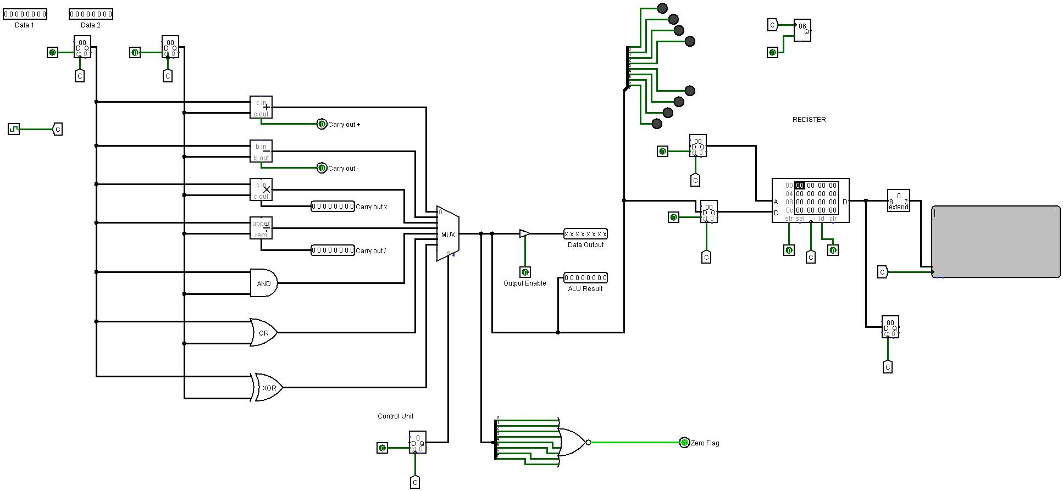
Figure 9: Improve ALU, RAM, OUTPUTS

I add Zero flag In ALU and Increase Ram Limit to 8 bits which mean now we can store things to 256 locations and I created circuits for JNZ and JMP which can be added to Control Unit and then to main circuit to perform Jumping with their specific conditions.
JMP:
It is used to Jump to load next specific Data in Microprocessor or we can also say to skip some data.
JNZ:
It is used to load to next data even the current data is null or zero.
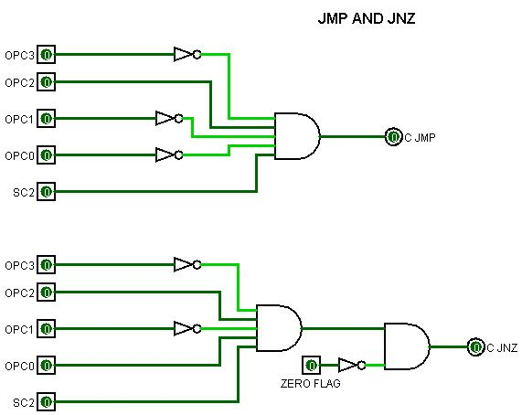
Figure 10: Circuits for JMP and JNZ

- After this Connect both of their outputs with OR gate.
- Add New 4-bit Multiplexer which (can take two inputs) on main circuit on the top right corner near the program counter.
- Connect 0 of mux with PC and 1 with IR and for function selector connect it with OR Gate output which was previously connect with output of JMP and JNZ
- And finally wire them manually or we can use tunnel to connect them with control Unit in main circuit.
- Our JMP and JNZ is ready to use.

9. Conclusion
This project successfully designed and implemented a fully functional 8-bit computer in Logisim, satisfying and exceeding the assessment requirements. The CPU was constructed entirely from a custom Memory Cell upward: 8-bit Registers, a 4-bit MAR, a seven-operation ALU, a ROM-based Decimal Decoder, and a two-part hardwired Control Unit generating 16 control signals (C0–C15). All seven ALU operations — including the instructions MUL, DIV, and XOR — were tested and confirmed correct.

The process of building the CPU from first principles provided insights beyond what textbook study alone can offer. Key lessons included the critical importance of testing each subcircuit in isolation before integration, the need to resolve wire width mismatches (red wires in Logisim) immediately, and the value of Tunnel components for managing complex signal routing without crossing wires. The hardwired control unit approach, while straightforward to trace, highlighted the scalability challenge that motivates microprogrammed designs in real processors an insight that connects directly to the broader curriculum of computer architecture.

10. References

Bright Space -- Logisim

Burch, C. (2023). Logisim-evolution. GitHub.
Link
( https://github.com/logisim-evolution/logisim-evolution )https://github.com/logisim-evolution/logisim-evolution )

Harris, D. M., & Harris, S. L. (2022). Digital design and computer architecture: ARM edition (2nd ed.). Morgan Kaufmann.
Link
( https://moodle.tktk.ee/pluginfile.php/270005/mod_resource/content/1/Harris%20D.%20M.%2C%20Harris%20S.%20L.%20-%20Digital%20Design%20and%20Computer%20Architecture%2C%202nd%20Edition%20-%202012.pdf )

Mano, M. M., & Ciletti, M. D. (2017). Digital design: With an introduction to the Verilog HDL, VHDL, and SystemVerilog (6th ed.). Pearson.
Link
( https://studentebookhub.com/wp-content/uploads/2024/preview/9780134549897.pdf )

Patterson, D. A., & Hennessy, J. L. (2021). Computer organization and design: The hardware/software interface: ARM edition (2nd ed.). Morgan Kaufmann.
Link
( http://home.ustc.edu.cn/~louwenqi/reference_books_tools/Computer%20Organization%20and%20Design%20ARM%20edition.pdf )

YouTube
Link
( https://youtu.be/lmWshn09nK4?si=flyeNWmnjTKNwMyl )


